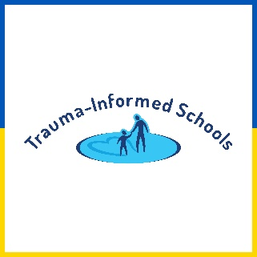
The effects of trauma may result in anger, disruptive behaviors, or dissociation in an attempt to protect themselves. Educators need to be aware of this reality in order to avoid discipline that further activates the student. When students are stressed, the elevated cortisol levels prevents them from engaging in rational thought. If educators are unaware of this possibility, there is potential for a harmful environment for students impacted by trauma.

